INTEGRATED CURRICULUM MAP
Year Four | AUTUMN (1)  1 wk |  |  | AUTUMN (1)  6 wks |  |  | AUTUMN (2)  6 wks |  |  | AUTUMN 2/SPRING (1)  1 or 2 wks |  |  | SPRING (1)  5 wks |  |  | SPRING (2)  4 wks |  |  | SPRING (2)  2 wks |  |  | SUMMER (1/2)  6 wks |  |  | SUMMER (2)  6 wks
Project  Title |   All About Me! |  |  |   It’s Top Secret! |  |  | Land of Fire & Ice   |  |  | Dragonology   |  |  | 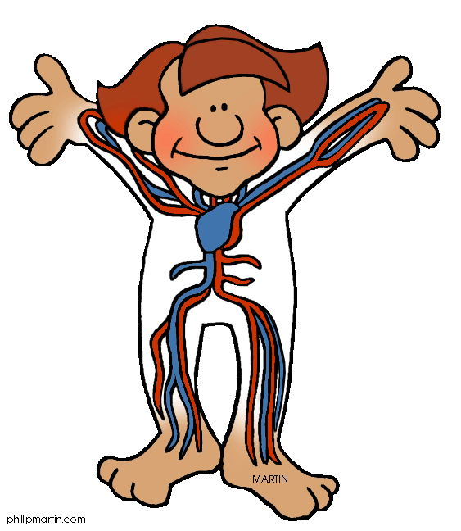  Operation Ouch |  |  |   Putting on a show! |  |  | Town Study  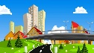 |  |  |   Romans |  |  | 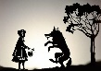  Shadows and Sounds
Lead Subjects | PDL | ENGLISH | ART | DT | ENGLISH | SCIENCE | GEOGRAPHY | ENGLISH | ART | ENGLISH | MUSIC | ART | SCIENCE | ENGLISH | DT | ENGLISH | HISTORY | MUSIC | GEOGRAPHY | ENGLISH | DT | HISTORY | ENGLISH | ART | SCIENCE | ENGLISH | MUSIC
Applied  Subjects | COMPUTING |  |  | COMPUTING |  |  | COMPUTING |  |  | PDL |  |  | COMPUTING |  |  | COMPUTING |  |  | COMPUTING |  |  | COMPUTING |  |  | COMPUTING
Applied  Subjects | MATHS |  |  | MATHS |  |  | PDL |  |  | COMPUTING |  |  | PE |  |  | PDL |  |  |  |  |  | GEOGRAPHY |  |  | ART
School Value | School Value :  All of the school values. |  |  | School Value :  Resilience |  |  | School Value: Kindness |  |  | School Value :  Excellence |  |  | School Value :  Growth |  |  | School Value :  Partnership |  |  | School Value :  Aspiration |  |  | School Value :  Achievement |  |  | School Value :  Trust
Hook | Getting to know one another. Everyone in Year 4 creates a box filled with items that represent them. Can you guess who each box belongs to? |  |  | There is a spy shortage and Year 4 will be working to achieve their Spy Licence throughout the project. |  |  | Southampton Airport are considering starting a flight route to Iceland but the managers need convincing. |  |  | Mysterious objects are discovered leading to an adventure…. |  |  | The Year 4 teachers have created their own ‘Operation Ouch!’ episode asking Year 4 to instruct PG pupils on how to look after themselves. |  |  | A message appears in Year 4 …. |  |  | A visitor comes to visit and asks for help with encouraging people to visit Fareham. |  |  | A time capsule has been dug up with a video message from a local historian who needs help to continue his life’s work. |  |  | Shadow Shows
Learning  Outcome | Character descriptions and self-portraits. |  |  | A Spy Gadget Fair… |  |  | Tourist Information Centre promoting Iceland. |  |  | A poetry and music performance. |  |  | Create an Operation Ouch episode on the digestive system, teeth and how to keep them healthy. |  |  | Perform Year 3/4 Show to families |  |  | Write a magazine article for Fareham Borough Council to persuade people to visit. |  |  | Living Museum to educate the public about how houses have changed over time and the Roman’s legacy. |  |  | Shadow puppet show for Year 1/2
Home Learning | Bring in a box containing 3 objects to represent your personality. |  |  | Create a Spy Kit. |  |  | Research and present an Icelandic recipe. |  |  | Learn a poem ‘The Dragon who Ate our School’. |  |  | Design a label for their healthy snack bar. |  |  | Create the artwork for the Year 3/4 show. |  |  |  |  |  | Make a model or a plan of a Roman Villa. |  |  | Make a poster to advertise the shadow show.
Text | First Day Jitters  When I Grow Up  Rosie Revere The Engineer  The Invisible Boy |  |  | Operation Gadgetman! |  |  | Race to the Frozen North |  |  | Tell Me a Dragon by Jackie Morris  Performance Poetry inspired by Nick Toczek |  |  | Demon Dentist |  |  | Linked to the performance |  |  |  |  |  | Queen of Darkness |  |  | The Lighthouse (Literacy shed video_

ENGLISH | MATHS | SCIENCE | HISTORY | GEOGRAPHY | ART | DT | MUSIC | PDL | COMPUTING | RE | PE

