Year Three | AUTUMN (1)  2 wks |  |  |  | AUTUMN (1)  5 wks |  |  | AUTUMN (2)  6 wks |  |  | AUTUMN (2)  2 wks |  |  | SPRING (1)  5 wks |  |  | SPRING (1/2)  5 wks |  |  | SPRING (2)  2 days | SUMMER (1)  5 wks |  |  | SUMMER (2)  4 wks |  |  | SUMMER (2)  3 wks
Project  Title | Me in Year 3   |  |  |  | Lost in Time   |  |  |   Exploring The Lakes |  |  | Christmas is Coming  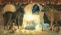 |  |  |   Uncovering Ancient Egypt |  |  |   Iron Man |  |  | Field Study    (Village) |   How does your Garden Grow? |  |  | Play the Game   |  |  | Let’s Explore Europe  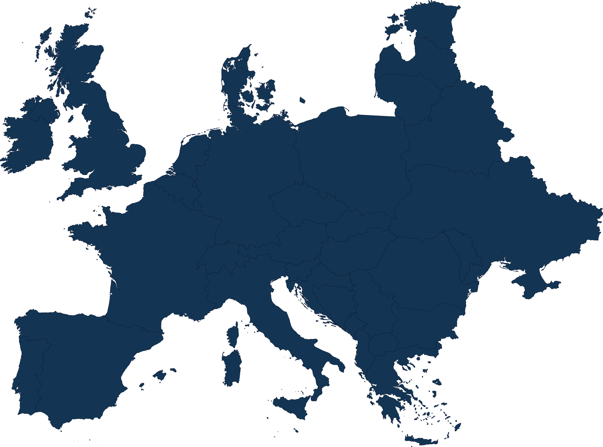
Lead Subjects | PDL |  | ENGLISH | ART | HISTORY | ENGLISH | ART | GEOGRAHPY | ENGLISH | SCIENCE | RE | ENGLISH | DT | HISTORY | ENGLISH | GEOGRAPHY | ENGLISH | COMPUTING | SCIENCE | GEOGRAPHY | SCIENCE | ENGLISH | ART | DT | ENGLISH | SCIENCE | ENGLISH | GEOGRAPHY | DT
Applied Subjects | COMPUTING |  |  |  | COMPUTING |  |  | COMPUTING |  |  | COMPUTING |  |  | COMPUTING |  |  | PDL |  |  |  | COMPUTING |  |  | COMPUTING |  |  | COMPUTING
Applied Subjects | MATHS |  |  |  | GEOGRAPHY |  |  | ART |  |  | PDL |  |  | PDL |  |  | ART |  |  |  | GEOGRAPHY |  |  | MATHS |  |  | ART
School Value | School Value:  All of them |  |  |  | School Value:  Partnership |  |  | School Value:  Excellence & Resilience |  |  | School Value :  Trust |  |  | School Value :  Resilience |  |  | School Value :  Aspiration |  |  |  | School value:  Growth  Resilience |  |  | School Value:  Partnership |  |  | School Value: Trust & Kindness
Hook | Ms Newman has asked for the shared areas showcase the best of Park Gate. |  |  |  | Find different farming tools in the outside area and discuss – order them. |  |  | Look at places that they have been on holiday – realise that they haven’t been to the Lake District and decide they are going to research this. |  |  | Lighting the first candle – visit to church |  |  | Discover a tomb in the classroom with clues about the next project (mummified cat, canopic jars, sarcophagus).  Egyptian Day |  |  | Y4 would like some audio books to enjoy. |  |  |  | Plant sunflowers and cress |  |  | We need new games for wet play. Bring board games in to play them. |  |  | Mrs Beazley has asked Year 3 to get ready for the new learning in Year 3 where they will be learning French.
Learning  Outcome | Shared area is transformed into an exhibition space. |  |  |  | Year 2 visit Year 3 and travel through time, revisiting their learning. |  |  | Parents are invited to attend a Lake District Visitors Centre. |  |  | Wrap Christmas decoration and discuss the end of Advent |  |  | Children present their findings to Year 6, ready for their future study of Ancient Civilisations. |  |  | Create an audio book for Year 4. |  |  |  | Take sunflowers home. Bee posters. |  |  | Year group mix and play the games. |  |  | An afternoon of sharing knowledge about Europe and sharing bread
Home Learning |  |  |  |  | Create a Stone Age meal |  |  | Beatrix Potter Research |  |  |  |  |  | Egyptian side profile drawing |  |  | Create the Iron Man or part of him |  |  |  | Design a new plant and label the scientific features. |  |  |  |  |  | Plan a day out somewhere in Hampshire to visit
Text | Picture Book Collection |  |  |  | The Boy with the Bronze Axe-  Kathleen Fidler |  |  | The Promise -  Nicola Davies |  |  | Nativity – different versions. |  |  | National Geographic Everything Ancient Egyptian |  |  | The Iron Man – Ted Hughes |  |  |  | The Tin Forest – Helen Ward |  |  | Manuals, instructions  The Day the Crayons Came Home – Drew Daywalt |  |  | Skysteppers -  Katherine Rundell

ENGLISH | MATHS | SCIENCE | HISTORY | GEOGRAPHY | ART | DT | MUSIC | PDL | COMPUTING | RE | PE

